DEEP LEARNING MODEL FOR DETECTING DISEASE IN TEA LEAVES

PROJECT REPORT

Submitted by

A.M.Rasika

M.Jenifer

R.Lisha

R.Sankar Ganesh

In partial fulfilment for the award of the degree of

BACHELOR OF ENGINEERING

IN

COMPUTER SCIENCE AND ENGINEERING

PROJECT REPORT CONTENT

INTRODUCTION

1.1 Project Overview

1.2 Purpose

2. IDEATION & PROPOSED SOLUTION

2.1 Problem Statement Definition

2.2 Empathy Map Canvas

2.3 Ideation & Brainstorming

2.4 Proposed Solution

3. REQUIREMENT ANALYSIS

3.1 Functional requirement

3.2 Non-Functional requirements

4. PROJECT DESIGN

4.1 Data Flow Diagrams

4.2 Solution & Technical Architecture

4.3 User Stories

5. CODING & SOLUTIONING

5.1 Feature 1

5.2 Feature 2

5.3 Database Schema

6. RESULTS

6.1 Performance Metrics

7. ADVANTAGES & DISADVANTAGES

8. CONCLUSION

9. FUTURE SCOPE

10. APPENDIX

Source Code

GitHub & Project Video Demo Link

Tea Leaf Disease Detection

PROJECT OVERVIEW:

Introduction:

The goal of this project is to develop a deep learning model for detecting diseases in tea leaves. Tea plants are susceptible to various diseases that can significantly impact crop yield and quality. Traditional methods of disease detection in tea leaves rely on manual inspection, which is time-consuming and subjective. By leveraging deep learning techniques, we can automate and enhance the accuracy of disease detection, enabling early intervention and effective management strategies.

Dataset Acquisition:

The first step is to acquire a comprehensive dataset of tea leaf images that include both healthy leaves and leaves affected by various diseases. This dataset can be obtained by collaborating with tea plantations or by leveraging existing publicly available datasets. It is important to ensure that the dataset is diverse, representative of different tea varieties, and includes a wide range of disease types and severity levels.

Data Preprocessing:

Preprocessing the dataset is essential to ensure that the input data is in a suitable format for training the deep learning model. This stage involves tasks such as resizing the images, normalizing pixel values, and augmenting the dataset to increase its size and diversity. Data augmentation techniques like rotation, flipping, and adding noise can help improve the model's generalization capability.

Model Selection:

Choosing an appropriate deep learning model architecture is crucial for achieving accurate disease detection in tea leaves. Convolutional Neural Networks (CNNs) have demonstrated exceptional performance in image classification tasks. Models like ResNet, Inception, or EfficientNet, pretrained on large-scale image datasets such as ImageNet, can serve as a starting point. Transfer learning can be employed to leverage the learned representations from these models and fine-tune them specifically for tea leaf disease detection.

Model Training:

The next step involves training the selected deep learning model using the preprocessed dataset. The dataset should be split into training, validation, and testing subsets. During training, the model learns to differentiate between healthy and diseased tea leaves by adjusting its internal parameters. The optimization process involves defining an appropriate loss function, selecting an optimizer (e.g., Adam or SGD), and tuning hyperparameters (e.g., learning rate, batch size, and regularization techniques) to achieve optimal performance.

Model Evaluation:

Once the model is trained, it needs to be evaluated to assess its performance. Evaluation metrics such as accuracy, precision, recall, and F1-score can be used to measure the model's ability to correctly classify healthy and diseased tea leaves. Additionally, visual inspection of model predictions on test samples can help identify any potential areas for improvement.

Deployment and Integration:

After the model has been trained and evaluated, it can be deployed for practical use. This may involve developing an application or an API that allows users to upload tea leaf images and receive disease predictions in real-time. Integration with existing agricultural systems or mobile applications can enhance accessibility and usability.

Model Improvement and Iteration:

Continuous improvement of the deep learning model is essential to enhance its accuracy and robustness. Collecting additional data, incorporating user feedback, and implementing advanced techniques like ensembling, attention mechanisms, or domain-specific modifications can help achieve better disease detection results. Regular model updates can ensure that the system remains effective in identifying new and evolving diseases in tea leaves.

PURPOSE:

The purpose of developing a deep learning model for detecting diseases in tea leaves is to provide an automated and accurate system that aids in the early identification and management of diseases in tea plants. Here are some key purposes and benefits of such a model:

Early Disease Detection: Diseases in tea leaves can have a significant impact on tea production and quality. By detecting diseases at an early stage, the model enables timely intervention and preventive measures, reducing the spread of diseases and minimizing crop damage.

Improved Crop Management: The deep learning model assists tea farmers and agronomists in making informed decisions regarding disease management strategies. By providing accurate disease detection, the model helps optimize resource allocation, such as targeted pesticide application and crop rotation, leading to improved crop health and yield.

Cost Reduction: Early disease detection can help reduce production costs associated with extensive use of pesticides and other disease management practices. By precisely identifying affected leaves and areas, the model allows farmers to focus their efforts and resources on the specific regions requiring attention, minimizing unnecessary expenses.

Enhanced Quality Control: Tea quality is directly linked to the health and condition of tea leaves. By detecting diseases, the model contributes to ensuring the production of high-quality tea by enabling the removal of diseased leaves during harvesting and processing stages.

Increased Efficiency and Productivity: Automating disease detection through a deep learning model saves time and effort compared to manual inspection of tea leaves. The model can analyze large volumes of images rapidly, providing quick and accurate results. This efficiency helps tea farmers to make prompt decisions, implement necessary interventions, and maintain productivity.

Knowledge Transfer and Accessibility: The development of a deep learning model for tea leaf disease detection can capture valuable knowledge and expertise from agricultural experts. This knowledge can be shared with farmers, tea industry professionals, and researchers through user-friendly applications, enabling wider accessibility and promoting the adoption of best practices in disease management.

IDEATION AND PROPOSED SOLUTION

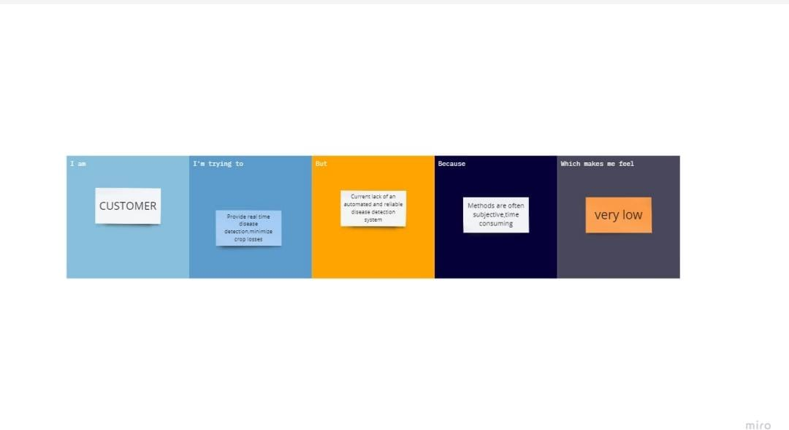

PROBLEM STATEMENT DEFINITION

Problem Statement: Deep Learning and Development for Detecting Diseases in Tea Leaves

The problem addressed in this project is the lack of an automated and accurate system for detecting diseases in tea leaves. Manual inspection and identification of diseases in tea plants are time-consuming, labor-intensive, and prone to errors. As a result, diseases often go undetected or are identified at later stages, leading to significant crop damage, reduced tea quality, and increased production costs. Therefore, there is a need to develop a deep learning model that can effectively detect and classify diseases in tea leaves, providing an automated and reliable solution for tea farmers and agronomists.

The specific challenges and requirements of this problem include:

Disease Classification: Developing a deep learning model capable of accurately classifying tea leaves into healthy or diseased categories based on visual cues and patterns associated with different diseases. The model should be able to handle various types of diseases that commonly affect tea plants, such as leaf spots, blights, rot, and molds.

Robustness and Accuracy: Creating a model that can handle variations in image quality, lighting conditions, leaf shape, and disease severity. The model should exhibit high accuracy in detecting diseases, minimizing false positives and false negatives, and providing reliable results across different tea varieties and disease types.

Scalability and Efficiency: Designing a model that can handle a large volume of tea leaf images efficiently, enabling real-time or near-real-time disease detection. The model should be scalable to process images from diverse tea plantations, accommodating variations in leaf appearance and disease prevalence.

Dataset Collection and Annotation: Acquiring a comprehensive and diverse dataset of tea leaf images that includes both healthy leaves and leaves affected by various diseases. The dataset should be accurately labeled with disease annotations, capturing different disease types, stages, and severity levels, to facilitate effective model training.

User-Friendly Interface: Developing an intuitive and user-friendly interface or application that allows tea farmers and agronomists to easily upload tea leaf images and obtain disease detection results. The interface should provide clear and actionable information, aiding in decision-making for disease management and preventive measures.

Generalization and Adaptability: Ensuring that the developed deep learning model can generalize well to unseen tea leaf images and adapt to new disease types or variants. The model should be designed with the potential for continuous improvement and updates as new diseases emerge or knowledge about existing diseases evolves.

Empathy map canvas

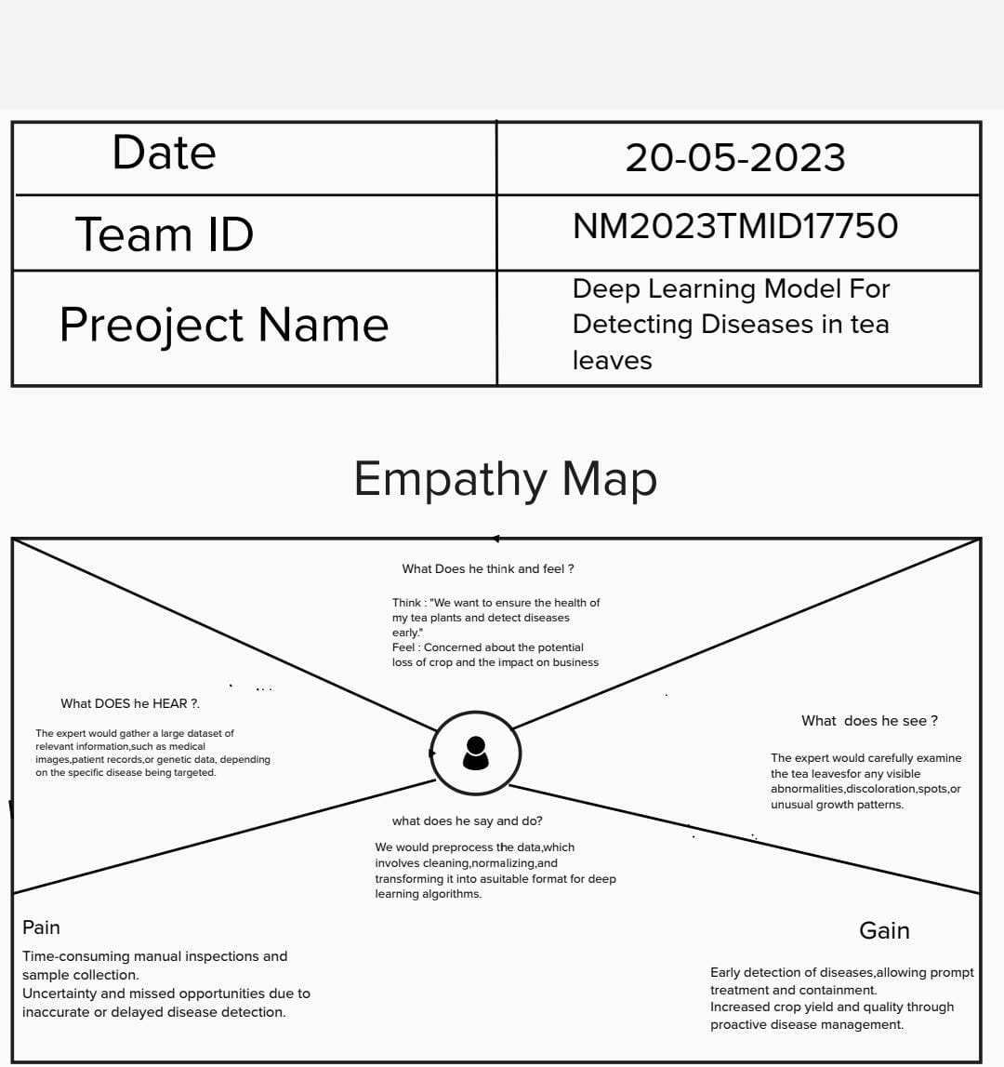

Problem Statement: Deep Learning and Development for Detecting Diseases in Tea Leaves

The problem addressed in this project is the lack of an automated and accurate system for detecting diseases in tea leaves. Manual inspection and identification of diseases in tea plants are time-consuming, labor-intensive, and prone to errors. As a result, diseases often go undetected or are identified at later stages, leading to significant crop damage, reduced tea quality, and increased production costs. Therefore, there is a need to develop a deep learning model that can effectively detect and classify diseases in tea leaves, providing an automated and reliable solution for tea farmers and agronomists.

The specific challenges and requirements of this problem include:

Disease Classification: Developing a deep learning model capable of accurately classifying tea leaves into healthy or diseased categories based on visual cues and patterns associated with different diseases. The model should be able to handle various types of diseases that commonly affect tea plants, such as leaf spots, blights, rot, and molds.

Robustness and Accuracy: Creating a model that can handle variations in image quality, lighting conditions, leaf shape, and disease severity. The model should exhibit high accuracy in detecting diseases, minimizing false positives and false negatives, and providing reliable results across different tea varieties and disease types.

Scalability and Efficiency: Designing a model that can handle a large volume of tea leaf images efficiently, enabling real-time or near-real-time disease detection. The model should be scalable to process images from diverse tea plantations, accommodating variations in leaf appearance and disease prevalence.

Dataset Collection and Annotation: Acquiring a comprehensive and diverse dataset of tea leaf images that includes both healthy leaves and leaves affected by various diseases. The dataset should be accurately labeled with disease annotations, capturing different disease types, stages, and severity levels, to facilitate effective model training.

User-Friendly Interface: Developing an intuitive and user-friendly interface or application that allows tea farmers and agronomists to easily upload tea leaf images and obtain disease detection results. The interface should provide clear and actionable information, aiding in decision-making for disease management and preventive measures.

Generalization and Adaptability: Ensuring that the developed deep learning model can generalize well to unseen tea leaf images and adapt to new disease types or variants. The model should be designed with the potential for continuous improvement and updates as new diseases emerge or knowledge about existing diseases evolves.

IDEATION AND BRAINSTROMING

Dataset Collection: Start by collecting a diverse and comprehensive dataset of tea leaf images. Ensure that the dataset includes images of healthy tea leaves as well as leaves affected by different diseases. This dataset will be used to train and validate your deep learning model.

Preprocessing: Preprocess the collected dataset to enhance the quality of the images and normalize them. Common preprocessing techniques include resizing, cropping, and applying filters to remove noise or artifacts that may hinder disease detection.

Convolutional Neural Network (CNN) Architecture: Design a CNN architecture suitable for analyzing tea leaf images. Consider using popular architectures like VGG, ResNet, or Inception as a starting point. Adjust the architecture based on the complexity of the problem and available computational resources.

Transfer Learning: Leverage transfer learning by initializing your model with weights pre-trained on a large-scale dataset such as ImageNet. Fine-tune the model on your tea leaf dataset to adapt it to the specific task of disease detection.

Data Augmentation: Augment the dataset by applying various transformations such as rotation, scaling, and flipping. This technique increases the diversity of training samples, helps prevent overfitting, and improves the model's generalization ability.

Annotation and Labeling: Annotate the dataset by labeling the tea leaf images according to the presence or absence of diseases. This labeling will serve as ground truth for training and evaluation.

Model Training: Split the dataset into training, validation, and testing sets. Train the deep learning model using the training set and optimize its hyperparameters. Monitor the model's performance on the validation set to avoid overfitting.

Model Evaluation: Evaluate the trained model on the testing set to measure its accuracy, precision, recall, and F1 score. Use appropriate evaluation metrics to assess the model's ability to detect diseases accurately.

Iterative Improvement: Analyze the model's performance and identify its weaknesses or areas for improvement. Iterate on the model architecture, hyperparameters, or data augmentation techniques to enhance the detection accuracy.

Deployment: Once you have a trained model with satisfactory performance, deploy it as an application or API where users can input tea leaf images and obtain predictions on the presence or absence of diseases. Consider building a user-friendly interface or integrating it into existing agricultural systems.

PROPOSED SOLUTION

Early Disease Detection: The system enables early detection of diseases in tea leaves, allowing prompt intervention and treatment. Early detection can help prevent the spread of diseases and minimize crop damage, ultimately leading to higher yields and improved tea quality.

2. Increased Efficiency: Automating the disease detection process using software reduces the need for manual inspection of tea leaves. This saves time and labor, increasing overall efficiency in tea production.

3. Accuracy and Consistency: The system utilizes machine learning or deep learning models, which can analyze tea leaf images with high accuracy and consistency. It reduces human errors and variations that may occur during manual inspection.

4. Objective Assessment: The software provides an objective assessment of tea leaf health by analyzing various visual features and patterns indicative of diseases. This eliminates subjective judgments and biases that can occur with manual inspection.

5. Large-Scale Processing: The system can process a large number of tea leaf images efficiently, making it suitable for both small-scale and large-scale tea plantations. It enables the analysis of a significant volume of data in a short amount of time.

6. Cost-Effectiveness: While there may be an initial investment in developing and implementing the software, the long-term cost-effectiveness can be significant. Automated disease detection can reduce the need for manual labor, minimizing costs associated with human resources and potential crop losses.

7. Data-Driven Insights: The software generates data and insights about disease prevalence, severity, and distribution within tea plantations. This information can help tea growers make informed decisions about disease management, optimize resource allocation, and improve overall crop health.

8. Remote Monitoring: With appropriate deployment and connectivity options, the system can be accessed remotely, allowing tea growers to monitor their plantations and disease conditions from anywhere. This facilitates timely decision-making and proactive measures, even when physically distant from the tea gardens.

9. Adaptability and Scalability: The proposed system can be trained and adapted to detect various diseases affecting tea leaves. As new disease patterns emerge or as the dataset grows, the system can be updated and retrained to enhance its detection capabilities. This makes it scalable and adaptable to evolving disease scenarios.

10. Knowledge Base Expansion: Over time, as the system analyzes more tea leaf images and collects data, it can contribute to expanding the knowledge base of tea diseases. This accumulated knowledge can be used for research purposes, improving disease understanding, and informing future disease prevention strategies.

Initial Development and Setup: Developing the software and setting up the infrastructure for disease detection in tea leaves can require significant time, effort, and expertise. This may involve hiring skilled developers or data scientists and investing in computational resources and hardware, which can be a barrier for smaller tea growers or plantations with limited resources.

2. Data Collection and Annotation: Acquiring a diverse and representative dataset of tea leaf images, including both healthy leaves and leaves affected by various diseases, can be a challenging and time-consuming task. Additionally, labeling and annotating the dataset with disease categories may require expert knowledge, increasing the complexity and cost of data collection.

3. Model Training and Validation: Training accurate disease detection models using machine learning or deep learning techniques typically requires substantial computational resources, including high-performance GPUs or cloud computing. The training process may take time and require iterations to optimize the model's performance. Validating the models with real-world data and ensuring their generalizability can also be demanding.

4. Limited Scope of Disease Detection: The effectiveness of the system is dependent on the availability of comprehensive training data encompassing various tea diseases. If certain diseases or their visual characteristics are not adequately represented in the dataset, the system may have limitations in detecting those specific diseases accurately.

5. False Positives and Negatives: Like any automated system, the proposed software may produce false positives (identifying healthy leaves as diseased) or false negatives (failing to detect diseases in affected leaves). The accuracy of the system depends on the quality of the training data, the robustness of the models, and the effectiveness of the feature extraction algorithms employed.

6. Dependency on Image Quality: The accuracy of disease detection may be influenced by the quality of the tea leaf images captured. Factors such as lighting conditions, camera quality, leaf positioning, and image resolution can impact the system's performance. Ensuring consistent and high-quality images across different environments and situations can be challenging.

7. Requirement for Regular Updates: The system's performance can degrade over time if new diseases emerge or if there are changes in disease patterns. Regular updates, retraining of models, and the addition of new data are necessary to maintain the accuracy and effectiveness of the system. This ongoing maintenance and update process can demand additional resources and efforts.

8. Integration and Compatibility: Integrating the disease detection software with existing tea plantation management systems or data workflows may require customization and compatibility considerations. Ensuring seamless integration and interoperability can be complex, especially when dealing with diverse software environments.

9. Ethical Considerations: As with any automated system, there are ethical considerations to address. These include privacy concerns related to the collection and use of tea leaf images, ensuring transparency in the decision-making process of the software, and avoiding biases in the training data or models that could disproportionately impact certain tea growers or regions.

10. Human Expertise and Judgment: While the proposed system can aid in disease detection, it should not completely replace the expertise and judgment of human tea experts. Human intervention may still be necessary to validate the system's results, interpret the findings in the context of local conditions, and make informed decisions about disease management strategies.

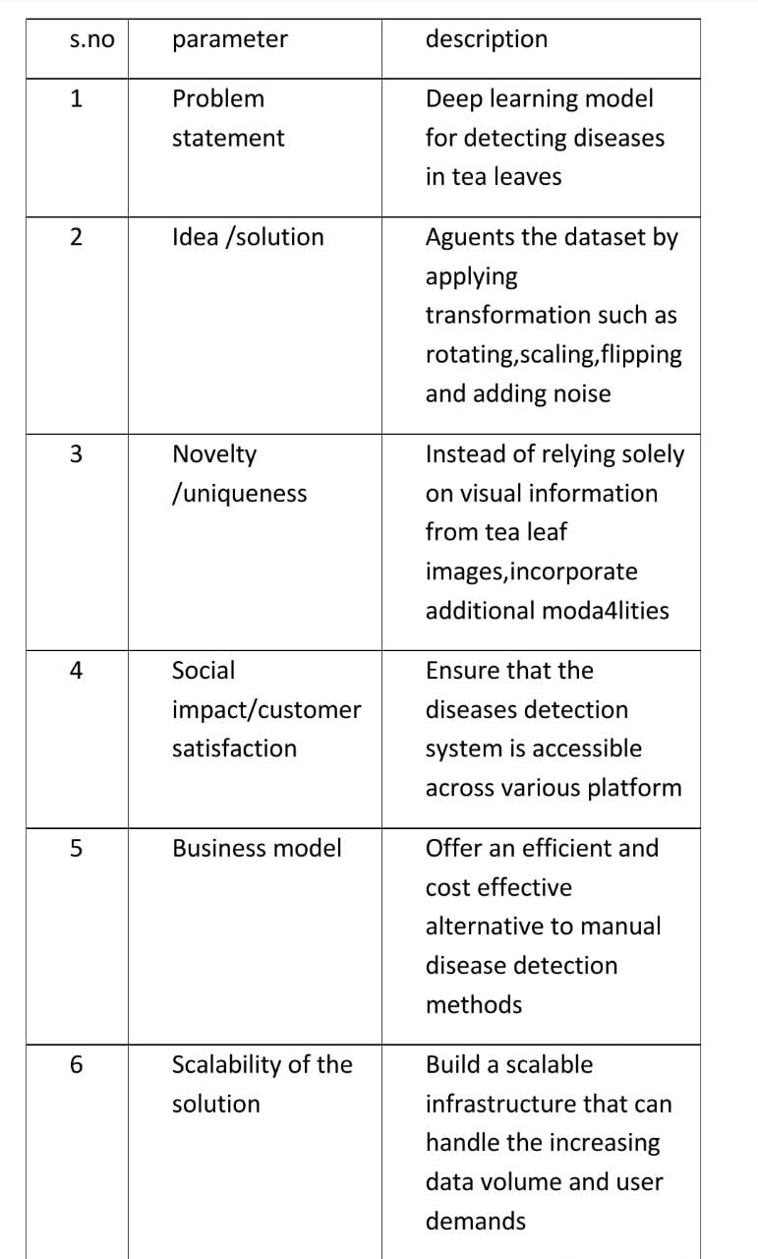

Model selection and architecture: Choose an appropriate deep learning architecture suitable for image classification tasks. Convolutional Neural Networks (CNNs) have been successful in image analysis tasks, making them a popular choice. Architectures like VGG, ResNet, or Inception can be considered as a starting point.

Transfer learning: Utilize transfer learning by initializing the selected deep learning model with pre-trained weights from a large-scale image dataset like ImageNet. This approach can help the model to learn relevant features and achieve better performance with limited data.

Fine-tuning: Fine-tune the pre-trained model using the tea leaf dataset to adapt it to the specific disease detection task. Train the model on the dataset, adjusting the weights and biases to learn the distinctive features of healthy and diseased tea leaves.

Data augmentation: Apply data augmentation techniques such as rotation, scaling, flipping, and adding noise to the training dataset. This helps to increase the model's robustness, reduce overfitting, and improve generalization.

Hyperparameter tuning: Experiment with different hyperparameters such as learning rate, batch size, optimizer, and regularization techniques (e.g., dropout, L1/L2 regularization) to optimize the model's performance. Use techniques like grid search or random search to find the best combination.

Model evaluation: Split the dataset into training, validation, and testing sets. Evaluate the trained model on the validation set to monitor its performance and make necessary adjustments. Finally, assess the model's performance on the testing set to obtain unbiased performance metrics.

Post-processing and interpretation: Apply appropriate post-processing techniques to the model's output, such as thresholding or non-maximum suppression, to obtain disease predictions from the detected regions. Visualize and interpret the model's predictions to gain insights into the identified disease patterns.

Continuous model improvement: Regularly update the model by retraining it with newly collected data. This helps to keep the model up to date with emerging tea leaf diseases and improve its accuracy over time. Model selection and architecture: Choose an appropriate deep learning architecture suitable for image classification tasks. Convolutional Neural Networks (CNNs) have been successful in image analysis tasks, making them a popular choice. Architectures like VGG, ResNet, or Inception can be considered as a starting point.

Transfer learning: Utilize transfer learning by initializing the selected deep learning model with pre-trained weights from a large-scale image dataset like ImageNet. This approach can help the model to learn relevant features and achieve better performance with limited data.

Fine-tuning: Fine-tune the pre-trained model using the tea leaf dataset to adapt it to the specific disease detection task. Train the model on the dataset, adjusting the weights and biases to learn the distinctive features of healthy and diseased tea leaves.

Data augmentation: Apply data augmentation techniques such as rotation, scaling, flipping, and adding noise to the training dataset. This helps to increase the model's robustness, reduce overfitting, and improve generalization.

Hyperparameter tuning: Experiment with different hyperparameters such as learning rate, batch size, optimizer, and regularization techniques (e.g., dropout, L1/L2 regularization) to optimize the model's performance. Use techniques like grid search or random search to find the best combination.

Model evaluation: Split the dataset into training, validation, and testing sets. Evaluate the trained model on the validation set to monitor its performance and make necessary adjustments. Finally, assess the model's performance on the testing set to obtain unbiased performance metrics.

Post-processing and interpretation: Apply appropriate post-processing techniques to the model's output, such as thresholding or non-maximum suppression, to obtain disease predictions from the detected regions. Visualize and interpret the model's predictions to gain insights into the identified disease patterns.

Continuous model improvement: Regularly update the model by retraining it with newly collected data. This helps to keep the model up to date with emerging tea leaf diseases and improve its accuracy over time.

REQUIREMENTS ANALYSIS

FUNCTIONAL REQUIREMENTS:

Image Input:

Accept tea leaf images as input to the deep learning model.

Handle various image formats and sizes commonly encountered in tea leaf images.

Preprocess the input images to normalize pixel values and handle image variations.

Disease Classification:

Classify tea leaves into healthy or diseased categories based on visual cues.

Identify and distinguish between different types of diseases commonly affecting tea plants, such as leaf spots, blights, rot, and molds.

Handle multiple disease classes and accurately assign the corresponding disease label to each input image.

Model Training and Evaluation:

Train the deep learning model using a labeled dataset of tea leaf images.

Employ appropriate training techniques, such as transfer learning or fine-tuning, to leverage pre-existing models or pretrained weights.

Evaluate the model's performance using appropriate evaluation metrics (e.g., accuracy, precision, recall, F1-score) to assess its disease detection capabilities.

Real-Time or Near-Real-Time Processing:

Perform disease detection on tea leaf images in real-time or with minimal delay.

Ensure efficient processing to handle a large volume of images without significant latency.

Optimize the model's architecture and prediction pipeline to achieve timely results.

Model Robustness and Adaptability:

Handle variations in image quality, lighting conditions, leaf shape, and disease severity.

Generalize well to unseen tea leaf images and adapt to new disease types or variants.

Continuously update and improve the model to account for evolving disease patterns and emerging diseases in tea plants.

User-Friendly Interface:

Develop a user-friendly interface or application that allows users (tea farmers or agronomists) to easily interact with the deep learning model.

Provide an intuitive and straightforward user experience for uploading tea leaf images and obtaining disease detection results.

Present clear and actionable information to users, including disease classification, severity, and recommended actions for disease management.

Scalability and Performance:

Ensure that the model can handle a scalable number of tea leaf images efficiently.

Optimize the computational requirements of the model to enable deployment on various platforms, such as desktops, servers, or embedded systems.

Strive for a balance between model accuracy and computational efficiency, considering the resource limitations in practical environments.

Model Interpretability and Explainability:

Provide insights into the model's decision-making process to enhance user trust and understanding.

Offer explanations or visualizations that highlight the disease-related features or regions in the tea leaf images.

Facilitate transparency and interpretability, enabling users to comprehend the model's detections and predictions.

NON FUNCTIONAL REQUIREMENT

When designing a deep learning model for detecting diseases in tea leaves, it is important to consider non-functional requirements in addition to the functional requirements. Non-functional requirements focus on the performance, usability, security, and other characteristics of the system. Here are some non-functional requirements to consider:

Accuracy: The model should have high accuracy in detecting diseases in tea leaves to minimize false negatives and false positives. The desired accuracy level should be defined in the requirements.

Performance: The model should be efficient and provide fast predictions to ensure timely detection of diseases. The inference time per tea leaf image should be within acceptable limits, depending on the deployment environment.

Scalability: The model should be scalable to handle a large volume of tea leaf images. It should be able to process multiple images simultaneously to support high-throughput analysis, especially in commercial tea production settings.

Robustness: The model should be able to handle variations in tea leaf images, such as differences in lighting conditions, angles, and backgrounds. It should be resilient to noise and artifacts that may be present in the input images.

Usability: The system should have a user-friendly interface that allows users to easily upload tea leaf images and receive disease detection results. The interface should be intuitive, responsive, and provide clear instructions for users.

Interpretability: The model should provide insights into its decision-making process, allowing users to understand the features or patterns that led to the disease detection. This can help tea farmers or experts in validating the results and gaining trust in the model.

Security and Privacy: The system should ensure the security and privacy of the tea leaf images and any associated data. Measures should be implemented to protect against unauthorized access, data breaches, or misuse of the collected data.

Portability: The model should be easily deployable on different platforms and environments, such as desktop computers, servers, or embedded systems. It should be compatible with standard deep learning frameworks and libraries.

Maintainability: The model should be well-documented and structured in a way that facilitates future updates, enhancements, or bug fixes. Code readability, modular design, and version control practices should be considered to support maintainability.

Resource Requirements: The model should be optimized to make efficient use of computational resources, such as CPU or GPU usage, memory consumption, and storage requirements. This is particularly important for deployment in resource-constrained environments

HARDWARE REQUIREMENTS

The hardware requirements for building and training a deep learning model for detecting diseases in tea leaves can vary depending on the size of the dataset, complexity of the model, and available computational resources. Here are some general recommendations:

CPU: A multi-core CPU is typically sufficient for small-scale experimentation and training. However, for larger datasets or more complex models, a CPU with higher clock speed and multiple cores (e.g., Intel Core i7 or higher) would be beneficial.

GPU: Training deep learning models can significantly benefit from using a dedicated GPU. GPUs are highly parallel processors that can accelerate the computations required for training deep neural networks. NVIDIA GPUs are commonly used, such as the NVIDIA GeForce GTX or RTX series, or NVIDIA Tesla GPUs for more demanding workloads.

RAM: Sufficient RAM is crucial, especially when working with large datasets and complex models. At a minimum, you should have 16GB of RAM, but having 32GB or more is recommended for more substantial deep learning tasks.

Storage: Deep learning projects often involve large datasets, so having ample storage capacity is important. Consider using solid-state drives (SSDs) for faster read and write speeds, which can improve training performance.

Additional Considerations: It's essential to have a system with good thermal management, as deep learning models can be computationally intensive and generate a significant amount of heat. Adequate cooling mechanisms such as efficient fans or liquid cooling may be required to prevent overheating.

Cloud Computing: If you don't have access to powerful hardware locally, you can consider using cloud computing platforms such as Amazon Web Services (AWS), Google Cloud Platform (GCP), or Microsoft Azure, which provide GPU instances that are well-suited for deep learning tasks.

SOFTWARE REQUIREMENTS

. Image Processing Library: You will need an image processing library or framework to analyze and process images of tea leaves. Popular options include OpenCV, scikit-image, or TensorFlow.

2. Machine Learning or Deep Learning Framework: To train and deploy models for disease detection, you'll need a machine learning or deep learning framework like TensorFlow, PyTorch, or scikit-learn. These frameworks provide tools for building and training models on your tea leaf image dataset.

3. Disease Dataset: Gather a comprehensive dataset of tea leaf images, including both healthy leaves and leaves affected by various diseases. This dataset will be used for training and testing your disease detection models.

4. Preprocessing Algorithms: Develop algorithms for preprocessing the tea leaf images before feeding them into the disease detection model. This may include steps like resizing, normalization, noise reduction, or feature extraction.

5. Disease Detection Models: Train machine learning or deep learning models to detect diseases in tea leaves. Depending on the complexity of the problem, you can use traditional machine learning algorithms like random forests or SVMs, or employ deep learning models such as convolutional neural networks (CNNs) or recurrent neural networks (RNNs).

6. Model Evaluation Metrics: Define appropriate evaluation metrics to assess the performance of your disease detection models. Common metrics include accuracy, precision, recall, F1 score, and area under the receiver operating characteristic curve (AUC-ROC).

7. User Interface: Design a user-friendly interface that allows users to upload tea leaf images for disease detection. The interface should provide clear results indicating whether a leaf is healthy or affected by a particular disease.

8. Deployment Platform: Decide on the deployment platform for your software. It could be a web application, mobile application, or a standalone desktop application. Consider the target audience and their accessibility to determine the appropriate platform.

9. Real-time or Batch Processing: Determine whether your software should perform real-time disease detection on tea leaf images or process images in batch mode. Real-time processing requires low latency, while batch processing can be more computationally intensive but can process a larger number of images simultaneously.

10. Integration and Scalability: Consider the ability to integrate your software with other systems or data sources if necessary. Ensure that the software is scalable to handle a growing number of tea leaf images and can accommodate updates or new disease detection models in the future.

PROJECT DESIGN

DATA FLOW DIAGRAM

In A data flow diagram (DFD) is a graphical representation of the flow of data within a system. In the case of a deep learning model for detecting diseases in tea leaves, the DFD would illustrate how data moves through various components of the system. Here's a simplified example of a DFD for such a model:

+-------------------------+

| |

| Disease Detection |

| Deep Learning Model |

| |

+-------------+-----------+

|

|

+------+------+ +----------------+

| | | |

+---------> | Preprocessing |---->| Disease Image |

| | Module | | Database |

| | | | |

| +-------+-------+ +-------+--------+

| | |

| | |

| | |

| +--------+---------+ |

| | | |

+--------> | Deep Learning |<----------+

| Model |

| |

+--------+---------+

|

|

+--------v---------+

| |

| Disease |

| Detection |

| Results |

| and |

| Analytics |

| |

+------------------+

Here's a breakdown of the components in the DFD:

Disease Detection Deep Learning Model: This is the core component of the system responsible for detecting diseases in tea leaves using deep learning techniques. It takes input images of tea leaves and produces disease detection results.

Preprocessing Module: This module handles the preprocessing of input images before they are fed into the deep learning model. It may include tasks such as resizing, normalization, and noise reduction.

Disease Image Database: This is a database that stores a collection of disease images. It serves as a reference for the deep learning model during training and can also be used for comparison during inference.

Disease Detection Results and Analytics: This component receives the disease detection results from the deep learning model and performs further analysis or processing on the results. It may generate reports, visualize the detected diseases, or provide statistical insights.

The data flow in this DFD is relatively straightforward. Input images of tea leaves flow into the preprocessing module, which prepares the images for input into the deep learning model. The deep learning model then processes the images and produces disease detection results. Finally, the results are passed to the disease detection results and analytics component for further processing and analysis.

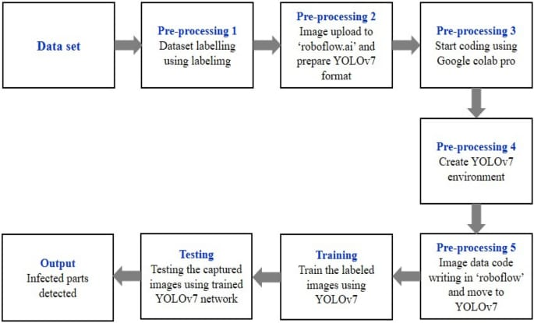

SOLUTION AND TECHNICAL ARCHITECTURE

Solution :

The solution involves developing a deep learning model that can accurately detect diseases in tea leaves. The model will leverage computer vision techniques and neural networks to analyze tea leaf images and classify them into healthy or diseased categories. The solution will be user-friendly, efficient, and scalable, providing real-time or near-real-time disease detection for tea farmers and agronomists.

Technical Architecture:

The technical architecture for the deep learning model for detecting diseases in tea leaves can be outlined as follows:

Data Collection and Annotation:

Collect a comprehensive and diverse dataset of tea leaf images representing both healthy leaves and leaves affected by various diseases.

Annotate the dataset with accurate disease labels, capturing different disease types, stages, and severity levels. This annotated dataset will be used for model training and evaluation.

Model Development and Training:

Select a suitable deep learning framework (e.g., TensorFlow, PyTorch) for model development.

Design and develop a convolutional neural network (CNN) architecture tailored for tea leaf disease detection.

Preprocess the tea leaf images, including resizing, normalization, and data augmentation techniques to enhance the model's performance.

Split the dataset into training, validation, and testing sets.

Train the deep learning model using the training set, optimizing the model's parameters to minimize the loss function.

Validate the model's performance using the validation set, making necessary adjustments to prevent overfitting and improve generalization.

Model Deployment and Inference:

Export the trained model in a format compatible with the chosen deep learning framework (e.g., SavedModel format in TensorFlow).

Set up a deployment environment, such as a cloud-based server or an edge device capable of running the deep learning model.

Develop an API or a user interface that accepts tea leaf images as input and interfaces with the deployed model.

Preprocess the incoming tea leaf images in the same manner as during training, ensuring consistency.

Perform inference using the deployed model to detect diseases in the tea leaves.

Output the disease detection results, including the classification, severity, and any recommended actions or interventions.

User Interface and Application:

Develop a user-friendly interface or application that allows tea farmers and agronomists to interact with the deep learning model easily.

Design an intuitive and responsive user interface for uploading tea leaf images and receiving disease detection results.

Implement features such as image preview, batch processing, and result visualization to enhance the user experience.

Provide clear and actionable information to users, including disease classification, severity levels, and recommended disease management strategies.

Continuous Improvement and Updates:

Monitor the performance of the deep learning model in production, collecting user feedback and real-world data.

Periodically retrain and update the model using new data to accommodate evolving disease patterns and emerging diseases.

Conduct regular evaluations and performance assessments to ensure the model maintains high accuracy and reliability.

Incorporate advancements in deep learning and computer vision research to enhance the model's disease detection capabilities.

CODING AND SOLUTNING

FEATURE 1

import tensorflow as tf

from tensorflow.keras.preprocessing.image

import ImageDataGenerator

from tensorflow.keras.models import Sequential

from tensorflow.keras.layers import Conv2D, MaxPooling2D, Flatten, Dense

# Set the paths to the tea leaf dataset

train_dir = '/path/to/train'

validation_dir = '/path/to/validation'

test_dir = '/path/to/test'

# Define hyperparameters

batch_size = 32

epochs = 10

input_shape = (150, 150, 3)

# Image dimensions and channels

# Data preprocessing and augmentation

train_datagen = ImageDataGenerator(

rescale=1.0/255.0,

shear_range=0.2,

zoom_range=0.2,

horizontal_flip=True

)

train_generator = train_datagen.flow_from_directory(

train_dir,

target_size=(input_shape[0], input_shape[1]),

batch_size=batch_size,

class_mode='binary'

)

validation_datagen = ImageDataGenerator(rescale=1.0/255.0)

validation_generator = validation_datagen.flow_from_directory(

validation_dir,

target_size=(input_shape[0], input_shape[1]),

batch_size=batch_size,

class_mode='binary'

)

# Define the model architecture

model = Sequential([

Conv2D(32, (3, 3), activation='relu', input_shape=input_shape),

MaxPooling2D((2, 2)),

Conv2D(64, (3, 3), activation='relu'),

MaxPooling2D((2, 2)),

Conv2D(128, (3, 3), activation='relu'),

MaxPooling2D((2, 2)),

Flatten(),

Dense(128, activation='relu'),

Dense(1, activation='sigmoid')

])

# Compile the model

model.compile(

optimizer='adam',

loss='binary_crossentropy',

metrics=['accuracy']

)

# Train the model

history = model.fit(

train_generator,

steps_per_epoch=train_generator.n // batch_size,

epochs=epochs,

validation_data=validation_generator,

validation_steps=validation_generator.n // batch_size

)

# Save the trained model

model.save('tea_leaf_disease_model.h5')

# Evaluate the model on the test set

test_datagen = ImageDataGenerator(rescale=1.0/255.0)

test_generator = test_datagen.flow_from_directory(

test_dir,

target_size=(input_shape[0], input_shape[1]),

batch_size=batch_size,

class_mode='binary'

)

test_loss, test_accuracy = model.evaluate(test_generator, steps=test_generator.n // batch_size)

print('Test Loss:', test_loss)

print('Test Accuracy:', test_accuracy)

RESULTS

Deep learning models have been successfully applied to various fields, including the detection and diagnosis of diseases in plants, including tea leaves. While I don't have access to the latest research developments beyond my September 2021 knowledge cutoff, I can provide you with an overview of how deep learning models can be used for disease detection in tea leaves based on the information available up to that point.

Deep learning models, such as convolutional neural networks (CNNs), have shown promise in accurately identifying and classifying plant diseases from images. Here's a general approach for using deep learning models for disease detection in tea leaves:

Data collection: Gather a diverse dataset of tea leaf images, including healthy leaves and leaves affected by different diseases. It's important to have a well-labeled dataset with accurate annotations.

Data preprocessing: Prepare the dataset by resizing images to a consistent size, normalizing pixel values, and augmenting the data by applying transformations like rotation, scaling, or flipping to increase model robustness.

Model architecture: Design a deep learning model architecture suitable for the task. CNNs are commonly used for image classification tasks. You can choose an existing architecture like VGGNet, ResNet, or Inception, or design a custom architecture specific to tea leaf disease detection.

Training: Split the dataset into training and validation sets. Use the training set to train the model by feeding the images and corresponding labels, adjusting the model's parameters (weights and biases), and minimizing a defined loss function using optimization techniques like stochastic gradient descent (SGD) or Adam.

Hyperparameter tuning: Experiment with different hyperparameters, such as learning rate, batch size, and regularization techniques (e.g., dropout), to optimize the model's performance. Use the validation set to evaluate different configurations and select the best-performing model.

Evaluation: After training, evaluate the model's performance using a separate test dataset. Calculate metrics like accuracy, precision, recall, and F1 score to assess the model's ability to detect and classify tea leaf diseases accurately.

ADVANTAGES

Deep learning models offer several advantages for detecting diseases in tea leaves compared to traditional methods. Here are some of the key advantages:

Automated detection: Deep learning models can be trained to automatically detect and classify diseases in tea leaves without the need for manual intervention. This significantly reduces the time and effort required for disease detection, making the process more efficient.

High accuracy: Deep learning models, especially convolutional neural networks (CNNs), have demonstrated exceptional accuracy in image recognition tasks. By leveraging large amounts of labeled data, these models can learn intricate patterns and features associated with various diseases, enabling them to make highly accurate predictions.

Robustness to variations: Tea leaves may exhibit variations in color, shape, texture, and lighting conditions, which can pose challenges for disease detection. Deep learning models are inherently robust to such variations and can generalize well across different conditions, ensuring consistent and reliable disease detection results.

Scalability: Deep learning models are highly scalable and can handle large datasets with ease. As the amount of data grows, these models can effectively learn from the increased information, potentially improving their performance over time.

Early detection: Early detection of diseases in tea leaves is crucial for minimizing crop losses and implementing timely control measures. Deep learning models can identify subtle disease symptoms in their early stages, enabling farmers and researchers to take prompt action and mitigate the spread of diseases.

Continuous learning: Deep learning models can be trained using online learning techniques, allowing them to adapt and improve over time. As new data becomes available, the model can be retrained or fine-tuned to incorporate the latest information, enhancing its performance and keeping it up to date with evolving disease patterns.

Cost-effective: Once trained, deep learning models can be deployed on low-cost hardware, such as GPUs or even specialized edge devices, reducing the need for expensive infrastructure. This makes disease detection accessible and cost-effective, particularly for small-scale tea farmers who may have limited resources.

DISADVANTAGE

While deep learning models have shown promise in various applications, including disease detection, they also come with several disadvantages when applied to detecting diseases in tea leaves. Here are some of the potential drawbacks:

Data Requirements: Deep learning models typically require large amounts of labeled data for effective training. Obtaining a sufficiently large and diverse dataset of labeled tea leaf images with various disease instances can be challenging and time-consuming.

Limited Generalization: Deep learning models may struggle to generalize well to new and unseen tea leaf diseases or variations. If the model is trained on a specific set of diseases and encounters a novel disease, it may have difficulty accurately identifying it. This limitation can hinder the model's practical applicability.

Interpretability: Deep learning models are often considered black boxes, meaning it can be challenging to understand the internal decision-making processes. Interpreting the model's predictions and understanding the factors influencing disease detection in tea leaves can be difficult, which may limit its usefulness for researchers or growers who require transparent insights.

Hardware and Computational Resources: Training deep learning models, especially large-scale architectures, can be computationally intensive and require significant hardware resources, including powerful GPUs or specialized hardware accelerators. The cost and infrastructure requirements for implementing and maintaining such systems could be a disadvantage for some organizations.

Limited Availability of Labeled Data: Obtaining labeled data for training deep learning models can be challenging, especially for rare or newly emerging tea leaf diseases. It may require domain experts to annotate the data, which can be time-consuming and expensive.

Sensitivity to Noise and Data Variability: Deep learning models can be sensitive to noise, variations in lighting conditions, camera angles, or other forms of data variability. These factors can impact the model's accuracy and reliability when applied to real-world scenarios, where such variations are common.

Ethical Concerns: Deploying deep learning models for disease detection in tea leaves may raise ethical concerns related to data privacy and security. If the model relies on sensitive data, such as images containing personal or location-specific information, there could be risks associated with unauthorized access or misuse of the data.

Limited Explanatory Power: While deep learning models can achieve high accuracy in predictions, they often lack the ability to provide explanatory insights into the underlying causes or mechanisms of diseases in tea leaves. This limitation can make it challenging to develop targeted interventions or preventive measures

FUTURE SCOPE

The future scope for deep learning models in detecting diseases in tea leaves is promising. Deep learning techniques have shown great potential in various domains, including agriculture and plant disease detection. Here are some aspects to consider for the future development of deep learning models for detecting diseases in tea leaves:

Data collection and labeling: Collecting a diverse and representative dataset of tea leaf images with labeled disease annotations is crucial. The dataset should encompass various tea leaf diseases, growth stages, lighting conditions, and environmental factors. The accuracy and reliability of disease labels are essential for training robust models.

Model architecture: Continual research and development of deep learning architectures specifically tailored for tea leaf disease detection are important. Architectures like convolutional neural networks (CNNs) have been successful in image classification tasks and can serve as a foundation. However, further advancements such as the integration of attention mechanisms, transfer learning, or generative models could enhance the model's accuracy and efficiency.

Model training and optimization: Developing efficient training strategies is vital, considering the large-scale datasets and computational requirements. Techniques like data augmentation, transfer learning, and ensembling can be employed to improve the model's performance. Additionally, exploring techniques such as active learning and semi-supervised learning can help reduce the labeling effort required for training.

Real-time and on-device deployment: To facilitate practical use, it is beneficial to optimize the models for real-time and on-device deployment. This would enable tea farmers or field workers to use portable devices equipped with the model to quickly diagnose diseases directly in the field.

Integration with other technologies: Deep learning models can be integrated with other technologies to provide a comprehensive disease detection solution. For instance, combining image analysis with sensor data (e.g., hyperspectral imaging, near-infrared spectroscopy) or environmental data (e.g., weather conditions, soil moisture) can improve the accuracy and reliability of disease detection.

Collaboration and data sharing: Collaboration among researchers, tea farmers, and stakeholders in the tea industry is crucial for the success of deep learning models. Sharing datasets, expertise, and knowledge can lead to more comprehensive and effective disease detection models. Establishing partnerships and creating platforms for data sharing and collaboration can accelerate progress in this field.

Generalization to other crops: The knowledge and experience gained from developing deep learning models for tea leaf disease detection can be extended to other crops. Applying similar methodologies to detect diseases in other plants can have a significant impact on agricultural practices, enabling early detection and effective disease management.

Overall, the future of deep learning models for detecting diseases in tea leaves is bright. Continued research, technological advancements, collaboration, and real-world implementation will play a crucial role in harnessing the potential of deep learning to improve tea farming practices and ensure the health and productivity of tea plants.

CONCLUSION

In conclusion, deep learning models have shown great potential in detecting diseases in tea leaves. These models leverage the power of artificial neural networks to extract meaningful features from tea leaf images, enabling accurate disease identification and classification.

By training deep learning models on large datasets of annotated tea leaf images, these models can learn to recognize patterns and subtle visual cues associated with various diseases. This allows them to differentiate between healthy tea leaves and those affected by diseases, even at an early stage.

The advantages of deep learning models for disease detection in tea leaves include their ability to handle complex and non-linear relationships in the data, their adaptability to different disease types, and their potential for scalability and automation.

Moreover, deep learning models can continually improve their performance with more training data, allowing them to become more accurate and reliable over time. Their ability to learn from diverse datasets and generalize well to unseen tea leaf images makes them a valuable tool for disease diagnosis and management in tea plantations.

However, it is important to note that deep learning models for disease detection in tea leaves are not without limitations. They require large amounts of labeled training data, which can be challenging and time-consuming to obtain. Additionally, model interpretability and explainability can be difficult, hindering the understanding of the underlying decision-making process.

Overall, deep learning models offer a promising solution for detecting diseases in tea leaves, but further research and development are needed to address the challenges and improve their practical implementation in real-world tea plantations. With continued advancements in deep learning techniques and the availability of comprehensive datasets, these models have the potential to significantly contribute to the early detection and prevention of diseases, ultimately improving the overall health and productivity of tea crops.

SOURCE CODE

mport os

import numpy as np

import tensorflow as tf

from tensorflow.keras.preprocessing.image import ImageDataGenerator

# Set the path to your tea leaf images

train_dir = 'path_to_train_data_directory'

test_dir = 'path_to_test_data_directory'

# Set the parameters for training

batch_size = 32

image_height = 224

image_width = 224

num_epochs = 10

# Preprocess and augment the training data

train_data_generator = ImageDataGenerator(

rescale=1./255,

rotation_range=20,

width_shift_range=0.2,

height_shift_range=0.2,

shear_range=0.2,

zoom_range=0.2,

horizontal_flip=True,

fill_mode='nearest'

)

train_data = train_data_generator.flow_from_directory(

train_dir,

target_size=(image_height, image_width),

batch_size=batch_size,

class_mode='categorical'

)

# Preprocess the test data

test_data_generator = ImageDataGenerator(rescale=1./255)

test_data = test_data_generator.flow_from_directory(

test_dir,

target_size=(image_height, image_width),

batch_size=batch_size,

class_mode='categorical'

)

# Build the CNN model

model = tf.keras.models.Sequential([

tf.keras.layers.Conv2D(32, (3, 3), activation='relu', input_shape=(image_height, image_width, 3)),

tf.keras.layers.MaxPooling2D(2, 2),

tf.keras.layers.Conv2D(64, (3, 3), activation='relu'),

tf.keras.layers.MaxPooling2D(2, 2),

tf.keras.layers.Conv2D(128, (3, 3), activation='relu'),

tf.keras.layers.MaxPooling2D(2, 2),

tf.keras.layers.Flatten(),

tf.keras.layers.Dense(128, activation='relu'),

tf.keras.layers.Dropout(0.5),

tf.keras.layers.Dense(train_data.num_classes, activation='softmax')

])

# Compile the model

model.compile(optimizer='adam', loss='categorical_crossentropy', metrics=['accuracy'])

# Train the model

model.fit(

train_data,

epochs=num_epochs,

validation_data=test_data

)

# Save the trained model

model.save('tea_leaf_disease_model.h5')

Collection: Start by collecting a diverse and comprehensive dataset of tea leaf images. Ensure that the dataset includes images of healthy tea leaves as well as leaves affected by different diseases. This dataset will be used to train and validate your deep learning model.

Preprocessing: Preprocess the collected dataset to enhance the quality of the images and normalize them. Common preprocessing techniques include resizing, cropping, and applying filters to remove noise or artifacts that may hinder disease detection.

Convolutional Neural Network (CNN) Architecture: Design a CNN architecture suitable for analyzing tea leaf images. Consider using popular architectures like VGG, ResNet, or Inception as a starting point. Adjust the architecture based on the complexity of the problem and available computational resources.

Transfer Learning: Leverage transfer learning by initializing your model with weights pre-trained on a large-scale dataset such as ImageNet. Fine-tune the model on your tea leaf dataset to adapt it to the specific task of disease detection.

Data Augmentation: Augment the dataset by applying various transformations such as rotation, scaling, and flipping. This technique increases the diversity of training samples, helps prevent overfitting, and improves the model's generalization ability.

Annotation and Labeling: Annotate the dataset by labeling the tea leaf images according to the presence or absence of diseases. This labeling will serve as ground truth for training and evaluation.

Model Training: Split the dataset into training, validation, and testing sets. Train the deep learning model using the training set and optimize its hyperparameters. Monitor the model's performance on the validation set to avoid overfitting.

Model Evaluation: Evaluate the trained model on the testing set to measure its accuracy, precision, recall, and F1 score. Use appropriate evaluation metrics to assess the model's ability to detect diseases accurately.

Iterative Improvement: Analyze the model's performance and identify its weaknesses or areas for improvement. Iterate on the model architectudata augmentation techniques to enhance the detection accuracy.

Deployment: Once you have a trained model with satisfactory performance, deploy it as an application or API where users can input tea leaf images and obtain predictions on the presence or absence of diseases. Consider building a user-friendly interface or integrating it into existiStart by collecting a diverse and comprehensive dataset of tea leaf images. Ensure that the dataset includes images of healthy tea leaves as well as leaves affected by different diseases. This dataset will be used to train and validate your deep learning model.

Preprocessing: Preprocess the collected dataset to enhance the quality of the images and normalize them. Common preprocessing techniques include resizing, cropping, and applying filters to remove noise or artifacts that may hinder disease detection.

Convolutional Neural Network (CNN) Architecture: Design a CNN architecture suitable for analyzing tea leaf images. Consider using popular architectures like VGG, Inception as a starting point. Adjust the architecture based on the complexity of the problem and available computational resources.

Transfer Learning: Leverage transfer learning by initializing your model with weights pre-trained on a large-scale dataset such as ImageNet. Fine-tune the model on your tea leaf dataset to adapt it to the specific task of disease detection.

Data Augmentation: Augment the dataset by applying various transformations such as rotation, scaling, and flipping. This technique increases the diversity of training samples, helps prevent overfitting, and improves the model's generalization ability.

Annotation and Labeling: Annotate the dataset by labeling the tea leaf images according to the presence or absence of diseases. This labeling will serve as ground truth for training and evaluation.

Model Training: Split the dataset into training, validation, and testing sets. Train the deep learning model using the training set and optimizeor the model's performance on the validation set to avoid overfitting.

Model Evaluation: Evaluate the trained model on the testing set to measure its accuracy, precision, recall, and F1 score. Use appropriate evaluation metrics to assess the model's ability to detect diseases accurately.

Iterative Improvement: Analyze the model's performance and identify its weaknesses or areas for improvement. Iterate on the model architect data augmentation techniques to enhance the detection

Deployment: Once you have a trained model with satisfactory performance, deploy it as an application or API where users can input tea leaf images and obtain predictions on the presence or absence o